

XIMURA Framework
System Design Specification
Version 0.9

This document is solely for the use of client personnel. No part of this document may be circulated, quoted or reproduced for distribution outside of the client organization without prior written approval of SLA Ltd unless permission is explicitly provided for in a relevant Consulting Services Agreement or applicable Appendix between the client and SLA Ltd.
Document Control
Document Information
Original Author | Paul Stancer
Document Status | Version 0.9
Project | XIMURA
Filename | 0000.doc

Distribution
Name | Company
Paul Stancer | SLA Ltd

Document Versions
Version | Date | Description | Prepared By
1.0 | 17 May 04 | Initial Draft Outline | Paul Stancer
1.1 | 4 July 03 | Draft | Sunny Lee

Statement of Confidentiality

The descriptive materials and related information in this document contain information that is confidential and proprietary to SLA Ltd and will not be disclosed, duplicated or used, in whole or in part, for any purpose other than evaluation of this document. This information is submitted with the express understanding that it will be held in strict confidence and not be re-distributed without the prior written consent of SLA Ltd, or where consent is included in a Consulting Services Agreement or applicable Appendix, between the Client and SLA Ltd.
Contents
Introduction 5
1.1 Executive Summary 5
1.2 System Overview 5
1.3 Design Constraints 5
1.4 XIMS Framework Components 5
XIMS Core System 10
2.1 Helper 10
2.2 Application 10
2.3 Command 10
2.4 Connectivity 10
2.5 Data 11
2.6 Dispatcher 11
2.7 Remoting 11
2.8 SecurityProvider 11
2.9 System Overview 11
Data Namespace 12
3.1 System Overview 12
3.2 Data Hierarchy 12
3.3 Content Entity 12
3.4 Folder Entity 12
3.5 Envelope Entity 13
Applications Namespace 14
4.1 System Overview 14
4.2 Dispatcher 14
4.3 Application 14
4.4 Command 15
Connectivity Namespace 16
5.1 System Overview 16
Remoting Namespace 17
6.1 System Overview 17
Windows Library 18
7.1 System Overview 18
Windows.Applications Namespace 19
8.1 System Overview 19
Windows.Toolkit Namespace 20
9.1 User Logon 20
9.2 Management Console Application 21
9.3 Management Console Layout 21
Table of Figures 22
Acceptance 23

Introduction

Executive Summary
This document is intended as a high level specification that details the overall capabilities of the XIMS core system.

This document outlines the discrete functional components that make up the XIMS system, and outlines the high-level capabilities of each components and how they fit together within the XIMS extensible framework.

System Overview
The XIMS system is an application framework that allows applications to be rapidly constructed from re-usable component base parts.

To promote code reuse and to reduce development time, the XIMS Framework implements and extends the .NET component model, enabling applications to be constructed using the drag-and-drop capabilities of the Visual Studio Development Environment. Developers can re-use code blocks from previous application with the minimum of coding by dropping system commands and UI components on to an application design surfaces provided by the XIMS framework.

Design Constraints
The XIMS system has been built using C# on Visual Studio.NET for version 1.1 of the Microsoft.NET Framework. XIMS has also been compiled and tested on the beta version 2.0 of the .NET Framework. The Linux platform is also supported as the core XIMS libraries are CLS compliant and have been compiled using MONO version 1.0.2 (see http://go-mono.com for details).

XIMS Framework Components
XIMS is composed of a number of primary components and libraries. The libraries are designed to provide generic application design solutions and are based on development best practices; being built around many common design patterns. However the Framework is flexible and component and parts of the system can be used externally without the need to deploy the full XIMS functionality.

XIMS.Applications
The Applications namespace provides the core of the XIMS functionality. This section will outline some of the key application components. The primary root objects in the Applcation namespace are:
- AppServer – this is an implementation of a specific set of business logic. This includes the full implementation including security and session management. AppServers are hosted in an Environment such as a Windows Service.
- Command – the command is the basic unit of business logic. There are many types of root command which a developer can use to implement specific types of business services. Commands can be shared and reused across many different applications, and can be linked together to provide quite complex business logic.

AppServer
At the heart of any XIMS application is the AppServer object which can be run in a number of environments. Developers can quickly deploy an application by dropping the AppServer object on to any XIMS environment platform without the need to write any additional application code. XIMS currently has built in support for Windows Services, Windows Forms and Windows console based applications; an ASP.NET environment platform container is currently in development. Future application environment will include support for Linux based Daemons and web based service using the mod_mono Apache plug-in, or as a Linux desktop application using Gtk#.

At the heart of the AppServer is the Dispatcher. The Dispatcher receives requests for Command services; this can from up-stream clients or internally from other Command objects. The Dispatcher ensures that the request are executed speedily and successfully. It does this by means of its built in job scheduler which utilizes a priority bases custom thread-pooler; during heavy load, high priority requests can jump ahead of lower based requests. The Dispatcher also monitor jobs and informs the client should their request time-out or exceed the maximum permitted time-slice.

Command requests which cannot be resolved locally can be passed to remote AppServer by means of special Command objects called Gateway Senders. Senders utilize .NET remoting to send requests to remote AppServers. Correspondingly AppServer can receive remote requests from a local Gateway Listener commands which submit these remote requests to the local Dispatcher for processing. [Chevron-Texaco currently use this architecture to implement robust load-balanced n-tier services using TCP/IP based Listener commands. ]

Command
Commands are the base unit of application functionality. Commands can be dropped in to any AppServer and can be shared across many different types of applications. Each command can be passed specific configuration information by the AppServer. XIMS currently contains a number of low-level command object which developers can inherit from to implement specific types of service; currently XIMS includes these basic command types:
- AppCommandBase – this is used to implement standard request/response capabilities;
- AppCommandProcess – this inherits from AppCommandProcess and can be used to implement commands that generate system events to specific external stimuli. A AppCommandProcess is assigned its own thread on start up and can generate requests to the dispatcher to be processed by other commands or passed to upstream Clients or downstream AppServers.
- AppCommandScheduleProcess – inherits from AppCommandProcess and in addition to that functionality includes a scheduled timetable to run specific tasks at regular intervals.
There are also a number of extended command classes which build on these base classes which provide additional capabilities:
- Protocol and TCPIPProtocol server – these commands inherits from AppCommandProcess and implement a high-volume protocol based client/server communication architecture using the finite-state machine design pattern. This enables the speedy construction of protocol based communication infrastructure. These commands also form the basis of the Gateway Listener/Sender commands which implement both TCP/IP and Named-pipes secure messaging architecture for the XIMS framework. These commands have also been used to provide high volume SMTP gateways and TCP/IP based financial ISO8583 messaging gateways.
- FTPBatchCommands – this is a hybrid of the AppCommandScheduleProcess and TCPIPProtocol Server command. This command can retrieve or send a file using FTP at a specified interval.
- ContentDataStore – the content data store is explained in more detail in the XIMS.Data section, but in brief it is an extensible component architecture which allows communication with a database or datastore to be abstracted. The CDS is a extended implementation of the CRUD (Create/Read/Update/Delete) design pattern.

UI
The AppServer concept has been extended and implemented at the presentation layer. The same application logic and services can be utilized to provide User Interface applications. Currently XIMS only supports Windows based application, but this will be extended shortly to include web based ASP.Net applications.

To enable rapid development and code reuse, XIMS implements this by means of a custom MVC (Model-View-Controller) architecture. This has been designed so that application logic can be reused for both Windows and Web based application, as the view can be either a windows screen or web based UIPage, but the business logic is implemented externally from these views.

Security and Session Management
The AppServer has an extensible security and session based capabilities. Every request handled by an AppServer must be sourced from a session object; including requests from internal AppCommandProcesses. Sessions are created by security managers which also verify all session requests to the Dispatcher and ensure that a user has the necessary privileges before executing a request. Developers can quickly implement their own custom Security Manager without the need to understand the in-depth working of the XIMS security mechanism. XIMS also includes the ability to chain sessions between multiple AppServers is a n-tier arrangement.

Logging and Performance
The AppServer has an extensive logging and performance capability which is implemented in a similar manner to the .NET Framework System.Diagnostics framework. The AppServer can log to multiple logging providers at the same time, and can log specific types of messages to different provider by means on the AppServer config file.

In addition the AppServer can record performance data to the Windows Performance sub-system, or to a custom performance provider.

Developer can quickly build custom performance and logging providers. Logging and Performance monitors can also be added to existing applications by means of the AppServer config file after the application has been deployed.

XIMS.Data
The XIMS.Data namespace contains the root classes that allow XIMS to persist, manipulate, convert and transmit information.

Content Object
The key object for the Data namespace is the Content object. The Content object is loosely based on the Composite design pattern and can contain custom data hierarchies of disparate data. The Content object is not confined to information that is stored in a database, but can include any form of binary information. Content derived objects also implement custom methods and properties to implement specific business logic to allow the data to be manipulated in a consistent manner.

There are several flavours on the root content objects, one specific type is the Data Content object which inherits from the base Content object and also wraps an ADO.NET Dataset; in addition to the standard data functions the Data Content enables design time data binding without the need to produce custom DataSets, as well as the ability to merge and update the existing data without the need for additional logic.

Serialization and Formatting
In addition to the manipulation of data, the Content object is also responsible for the serialization of data to enable it to be safely passed across application and process boundaries and reconstituted in the same format on the other side. This enables developers to quickly create complex data entities without the worry of having to specify the complex code of how to transmit them.

XIMS Content object can also provide Metadata which specifies how the serialized object can be formatted. This can be used in a suprising way: one specific example of this was for a SMTP server where the MIME formatting was accomplished using a Serialization formatter. This ensured that the logic to provide MIME formatted binary emails and to covert the MIME back in to a Content object that could be manipulated was separate from the Content object itself. Should the formatting change in the future, the Email Content object would remained unchanged.

Persistence Management and the Content Data Store
The XIMS system features a persistence storage mechanism called the Content Data Store or CDS for short. The CDS is primarily concerned with the persistence and management of Content objects. Primarily this is through the 4 operations of the CRUD design pattern (Create/Read/Update/Delete) but in the CDS this has been expanded to include Version Check for caching purposes and Custom for future capabilities.

Technology wise, the CDS is blind to the technologies used to persist these Content entity object; it could be a relational database such as SQL Server 2000 or Oracle 9, or simply a folder in a file system. In fact the storage mechanisms can be changed on the fly by means of the CDS configuration file, enabling persistence mechanisms to be added or updated simply and easily after an application has been deployed.

The CDS can contain many types of persistence mechanisms for many different types of Content object. To enable the CDS to correctly identify the relevant mechanism the Content objects supply metadata that advises the CDS on how the various actions can be implemented. Content object may provide multiple declarations for the same operation, or specify that certain operations are not supported.

Content metadata directives can be overridden in the configuration file. The CDS can also be directed to try multiple Persistence Managers, or to try a Persistence Manager on another CDS on a remote server. This is specifically useful in caching scenarios.

Ximura Application Server
The core system contains the components that make up the XIMS system. The system is broken up in to a number of discrete namespaces that define specific functionality.

Helper
The helper namespace contains utilities that allow the XIMS system to use common functionality for common tasks. Services such as configuration file support, compressions algorithms or specialized collection classes are all contained within the helper libraries. Developers should add commonly used classes or methods to this namespace.

Application
The Application namespace contains the necessary classes and methods that allows commands to work together as an application. The primary class within the application namespace is the application class which implements all the basic functionality for an application, including such services as thread pooling and object pooling for command instances. The application class can also be extended for specific environment. Windows applications extend the basic application framework when building XIMS based windows applications.

Connectivity
The connectivity namespace contains logic which deals with remote communication, and the servers logic to provide robust communication servers. This functionality is used by XIMS to provide both advanced remoting architecture and advanced communication services, such as multithreaded communication server applications. Connetivity supports protocols such as TCP/IP and named pipes, as well as the authentication and security protocols such as SSL and SSPI integration.

Data
The data namespace contains the root classes that allows XIMS to store, manipulate and transmit information around a XIMS based system.

Session Manager

SecurityManager (SCM)

Dispatcher

Command
The command is the basic unit of executable logic. XIMS based applications are built up by the communication between modules derived from the command class. Commands receive requests and return responses. There are many different types of commands, which enables XIMS to deal with a variety of specific application types, which are detailed later in the command namespace section.

System Overview
The helper namespace contains a number of useful utilities used by XIMS based applications.

Data Namespace

System Overview
Information that is passed between components in the XIMS namespace and displayed to users of the display based interfaces, is inherited from the basic Data object. Information that is stored within the data object can be stored and manipulated easily within the XIMS system. Data entities can also be passed between process boundaries easily as the Data object includes inbuilt support for serialization and deserialization.

Data Hierarchy
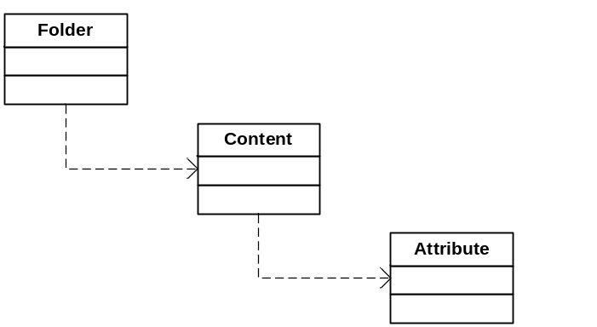
Figure 1 - Data Object Hierarchy

Content Entity
The content entity is the default data object within the XIMS system. The content entity is essentially an extended

Data Content Entity
The Data Content Entity contains data stored as a collection of disconnected ADO.NET Datasets. Data Entities can be loaded directly from the return values of a stored procedure.

XML Content Entity
The XML Content Entity operates in a similar manner to the Data Content Entity, except that the datastore for the object is an XML object.

Folder Entity
The Folder Entity is a object that can contain zero or many parameters entities as well as zero or many Content Entity objects.

Envelope Entity
The Envelope Entity is a container that can contain zero or many Folder Entities. Envelopes are used to transport Folder across domain boundaries, or to securely serialize a collection of Folders.

Applications Namespace

System Overview
The application namespace in the primary engine for the XIMS system. There are 3 primary objects within the Application namespace which are used to construct a XIMS based application.

Dispatcher
The Dispatcher is the base object than manages and hosts an application. Usually there will be one dispatcher onject per process. A system can have multiple dispatchers instances running on a single machine, but the dispatcher will have it’s only private process. Communication between commands and other applications in separate dispatchers will be by means of inter-process calls, such as Named Pipes or TCP-IP based remoting interfaces.
Dispatcher’s usual host a single applications, but can host multiple applications where needed. Dispatcher instances can be hosted by Windows services where they are server based applications, or by IIS for web based applications, or by a windows based executable for user interface based applications.

Application
The application is the primary grouping of system functionality. Applications host objects inherited from the Command object. The command is the primary unit of application logic within the system, and the application manages requests from remote applications or other commands for a partuiculr command.

Each application has its own managed thread pool, which allows it to carefully manage job requests so that it can process work requewsts as efficiently as possible.

There are several types of applications. Windows based applications inherit from the root application object, and have additional logic which allows them to interact with the Windows grapohical operating system. IIS based applications also inherit from the base application object, and also have additional logic whdic allows them to interact effectively with IIS.

Applications also manage the secutrity aspects of hosting application logic, and check each request against a user session object.

Command
There are several types of command, all of which are inherited from the base Command object.

Command
The command object is the base object for process a request and returning a response. Commands accept a Folder object for the request and return a new folder object as a response.

Command Process
Command process objects operate in a similar fashion to a standard command, but also have the ability to create their own requests to the base application for processing. Process commands can also request their own process thread from the base application to enable them to monitor long running requests, or objects such as TCP/IP connections. Process commands are ideally suited to running processes such as TCP/IP listeners for systems such as SMTP mail servers for instance.

Function
Commands functions are primarily concerned with managing requests from external parties and processing the corresponding responses. In a sense a command function operates in a reverse manner to a command. Functions are primarily concerned with managing user interaction with a XIMS based system. Functions operate within the same application framework as a command. Functions can contain a large amount of business logic and may utilize the application thread pool to process complex requests simultaneously.

Connectivity Namespace

System Overview
The Connectivity namespace is concerned with providing a robust networking architecture for client and server based networking applications. The connectivity namespace functionality is independent of the transport layer and can be used for multiple protocols. Named Pipes and TCP/IP are currently supported within the connectivity framework.

The connectivity namespace is also used by the remoting sub-systems as a robust and secure layer from which to marshall remote calls over.

Remoting Namespace

System Overview
The remoting namespace contains the functionality for supporting remote connections between XIMS based systems using a variety of communication protocols. Call marshalling is implemented using the high level .NET remoting functionality and the communications layer in implemented using the XIMS Connectivity Functionality.

The remoting namespace will support remote logon for interconnected XIMS based systems, be they windows based applications or server based applications.

Windows Library

System Overview

Windows.Applications Namespace

System Overview

Windows.Toolkit Namespace

User Logon
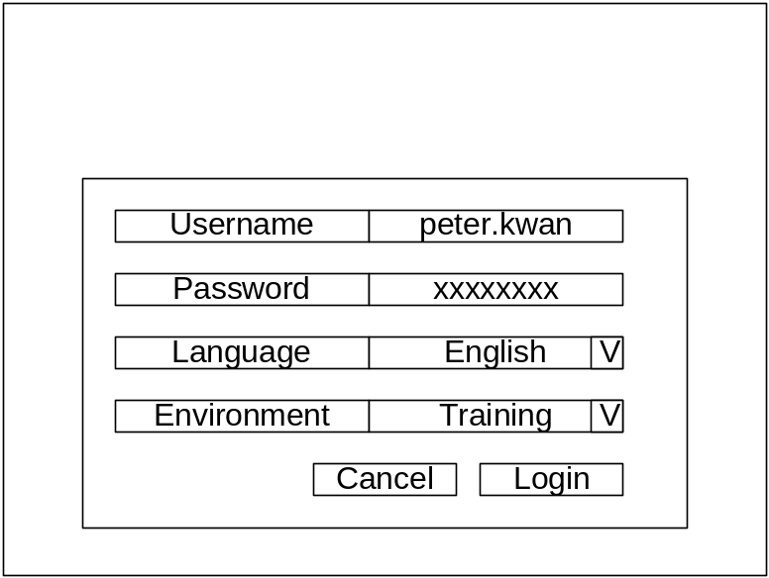

Overview
The User Log-on window allows a user to log on to the Loyalty Points System Management Console. This window will appear when the user first starts the application.
This screen will also appear after the user’s session has been idle for a predetermined period of time.

Username

Password

Language

Environment
User can choose the environment which they want to logon to. Environments may include “Production”, “Staging”, “Development”, and “Training”.

Security

Management Console Application

Overview
The Management Console Application is used to host the various system modules that make up the LPS Management Interface. Modules will be displayed based on a user’s specific security profile.

Security

Menu Structure

Management Console Layout
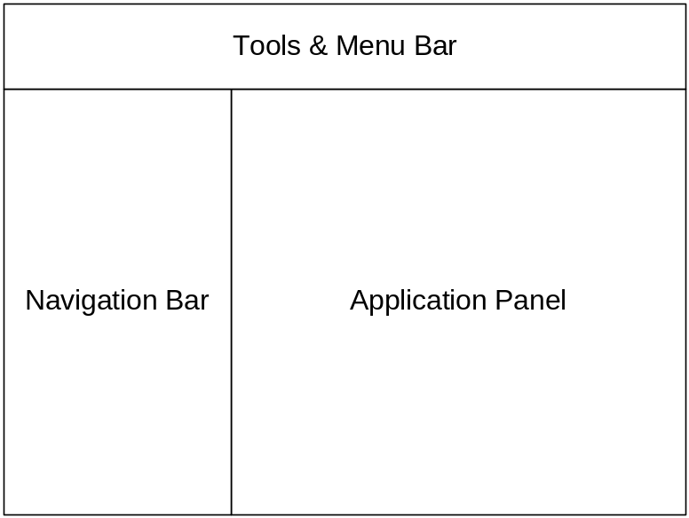

Panel – Tool and Menu Bar

Panel – Navigation

Panel – Application Panel

Table of Figures
Figure 1 - Data Object Hierarchy 12

Acceptance
The following signature indicates acceptance by of this System Design Specification document Version 0.9.

For and on behalf of:

Authorized
Employee’s
Signature:

Name:

Title:

Date:

SLA Ltd
Authorized
Employee’s
Signature:

Name: Paul Stancer

Title: Technology Director

Date:

[Document Ends]

